RESUME COMPUTER NETWORK
Computer networks are collections of computers that are connected to each other using communication protocols. Basic principle of computer networks is the occurrence of two-way communication between the sender and receiver of information.
Based on the vast territory, I use a LAN (Local Area Network) is a local computer network, the area is very limited. Media that can be used for a LAN cable (UTP or BNC) and wireless.
Based on the configuration, I use a peer-to-peer is used on the network with fewer number of computers, where each - each computer has an equal status and does not require a centralized system (server).
The tools necessary to create a network, it is;
- Twisted Pair (UTP) is a cable consisting of pairs - insulated conductor pair and widely used
for ethernet and telephone networks.
- Crimp Tool, is a tool to install the UTP cable into the RJ-45 connector. Serves to cut and peel wires.
- RJ-45, is konektur eight wires that are typically used to connect a computer to a LAN, especially Ethernet.
- LAN Tester is used to check the cable connection on a local network (LAN). This tool is equipped with LED lights as an indicator connected / absence of a wired network.
- NIC (Network Interface Card), commonly referred to as LAN card or a network card. Used as an interface (interface) computers with a network of computers that can communicate with each other.
To create a computer network (LAN) can be through a cable or wireless communication media. LAN wiring technique using twisted pair cable UTP type, consisting of 8 copper wires with different colors - different pairs were grouped into 4 color groups, namely: orange, green, blue and brown.
The technique used is cross-wiring (cross) is used to connect 2 computers directly (without a switch / hub). In the cross-wiring technique, which pin on the end of the first cable wiring diturutkan as straight, but at the end of the second crossing occurs (cross). Crossing using formulas 1-3, 2-6 which means pin-1 at the end of the first cable will meet the third pin on the end of the second cable, and pin-2 at the end of the first cable will meet to-6 pin cable on the end of the second . For more details, please see the following table:
End To 1 |  | End To 2
Pin | Color | Pin | Color
1 | Orange – White | 3 | Green – White
2 | Orange | 6 | Green
3 | Green – White | 1 | Orange – White
4 | Blue | 4 | Blue
5 | Blue – White | 5 | Blue – White
6 | Green | 2 | Orange
7 | Brown – White | 7 | Brown – White
8 | Brown | 8 | Brown

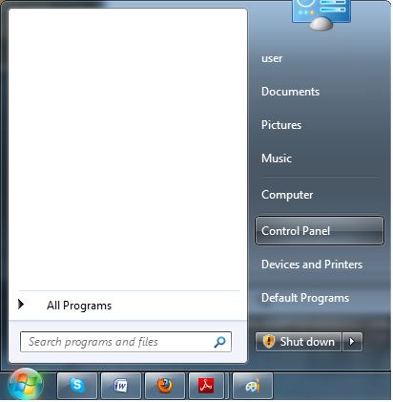
After doing engineering wiring, replace all subsequent network equipment properly configure the IP address on the computer. Next step - step setting the IP address on Windows 7 operating system:
- Open the Control Panel, click the Windows button, select Control Panel.

- In the Control Panel, select Network and Sharing Center.
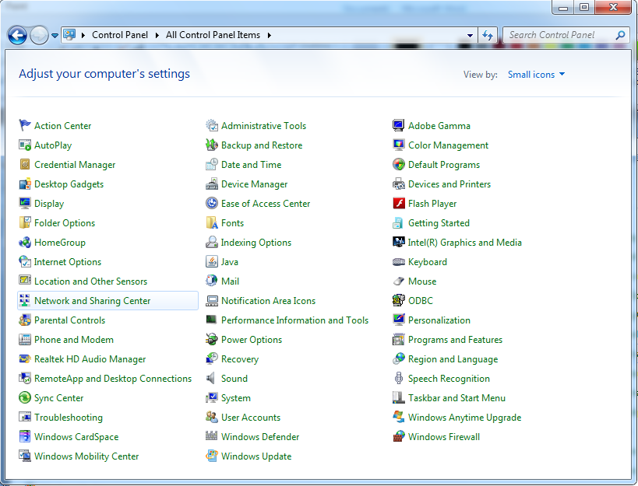

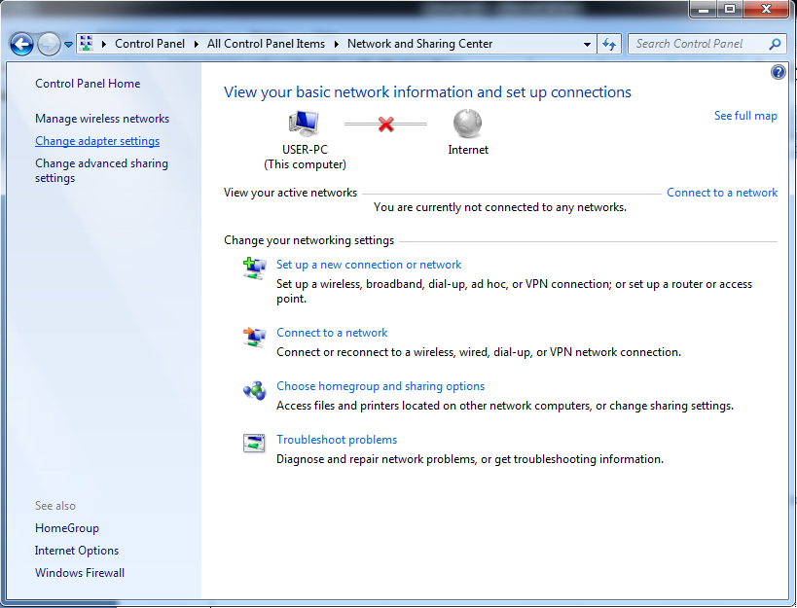
- Then select Change Adapter Settings.

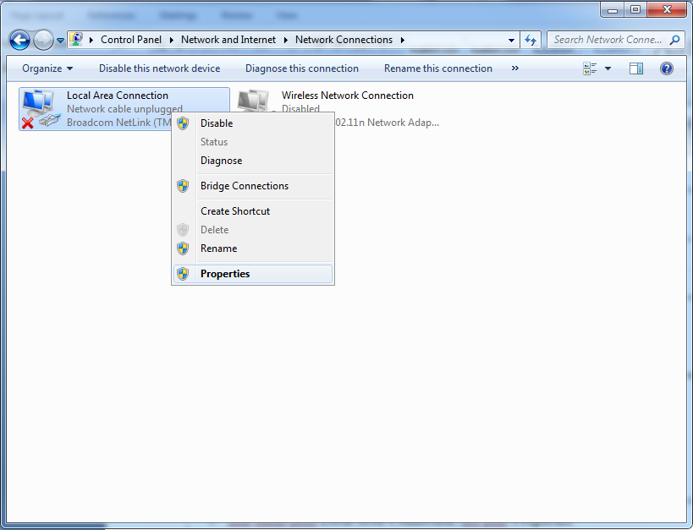
- Right-click on Local Area Connection and select Properties.
- Then select Internet Protocol Version 4 (TCP/IPv4), and then select Properties.
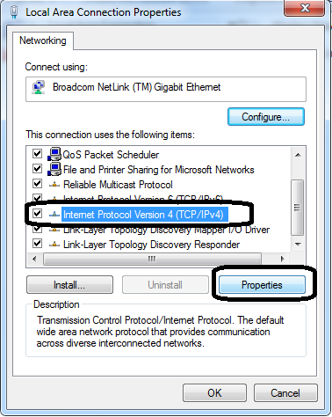
.

.
- Select Use the following IP address, then enter the IP address, subnet mask, and gateway configuration appropriate, and then click OK.
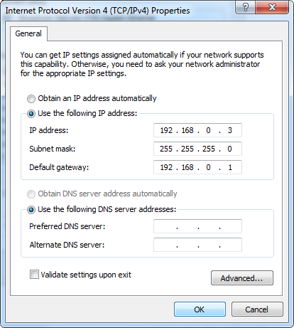
One advantage of using a computer network is its ability to share (share) files between computers in the network, each computer kerana can directly interact with other computers. Here are the steps - steps to share configuration files via Windows 7 Homegroup
- Open the Control Panel, click the Windows button, select Control Panel.

- Menu Control Panel, pilih Network and Sharing Center.

- Then select Choose homegroup and sharing options.
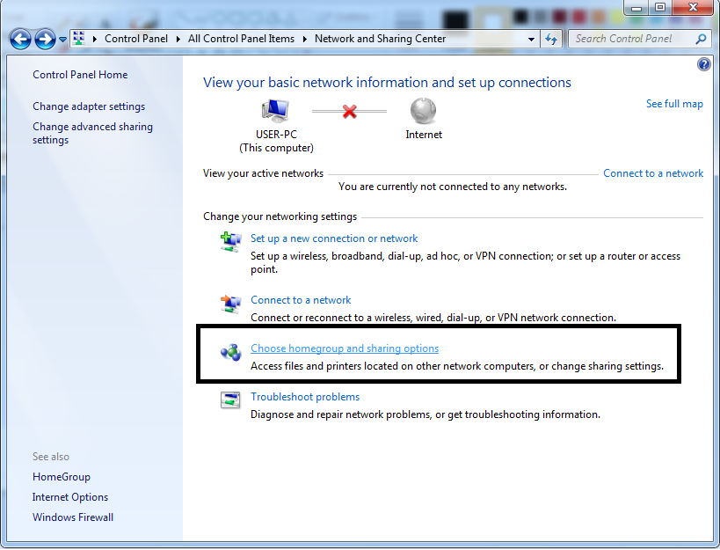
- Next select the What is a network location?.
- Then select Home network.
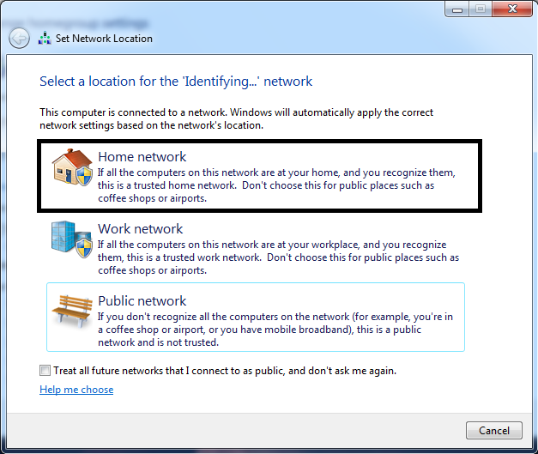

- Wait a while until the process is complete.
- Tentukan pilihan file yang akan di-share, lalu klik Next.
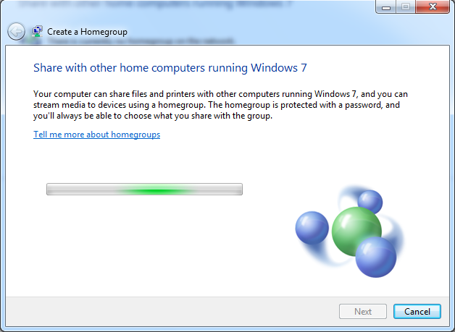
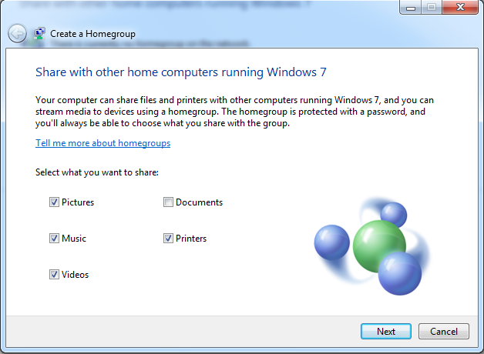

- Wait a while until the process is complete.
- Next comes the code (password) that will be used by other computers to access the homegroup. Write down this password, hereinafter click Finish.
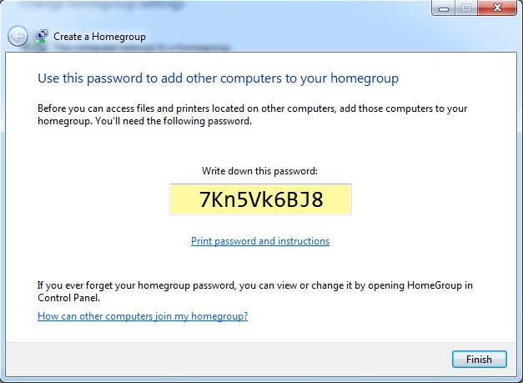

- When finished, click Save Changes.
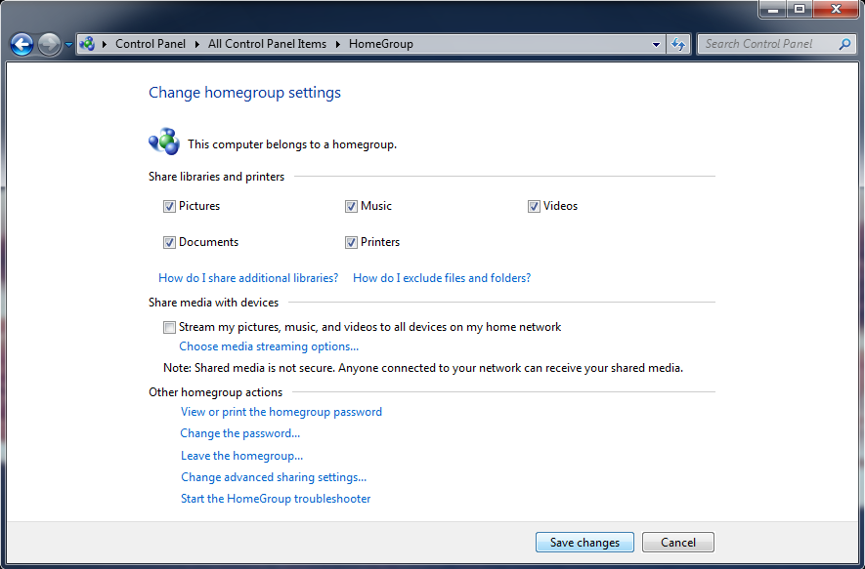
After configuring the IP address setting in Windows 7, we then share files between Windows 7 and Windows XP to be connected and file sharing (peer to peer).
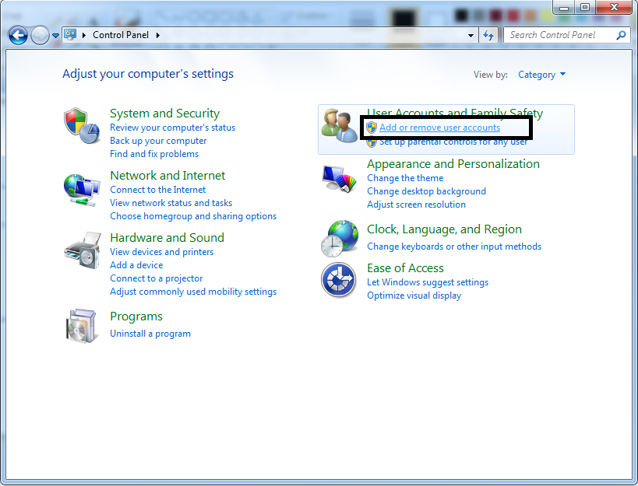
- In windows 7, create a new user. Open the Control Panel, select Add or Remove User Accounts.

- Select Create a new account.
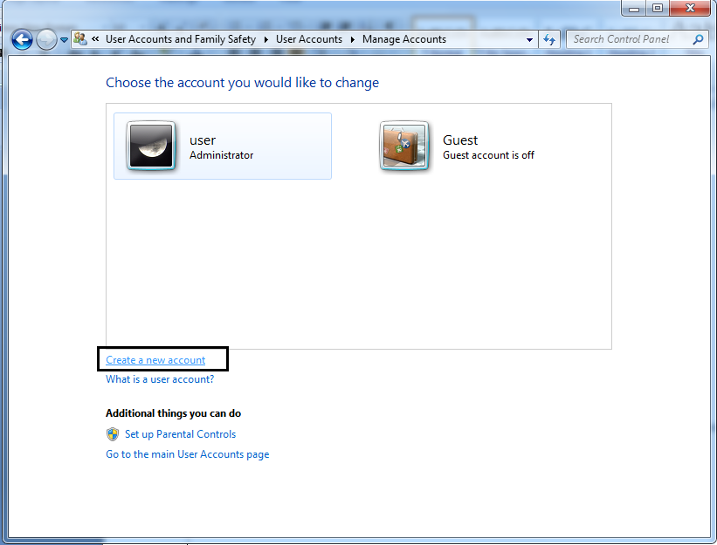
- Fill in the username and specify the type of user. Then click Create Account.
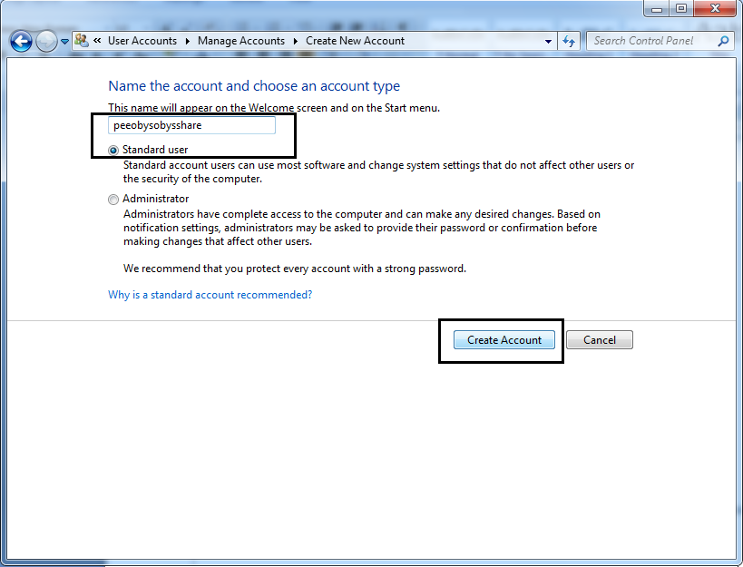
- Select the newly created user, and then click Create a password.
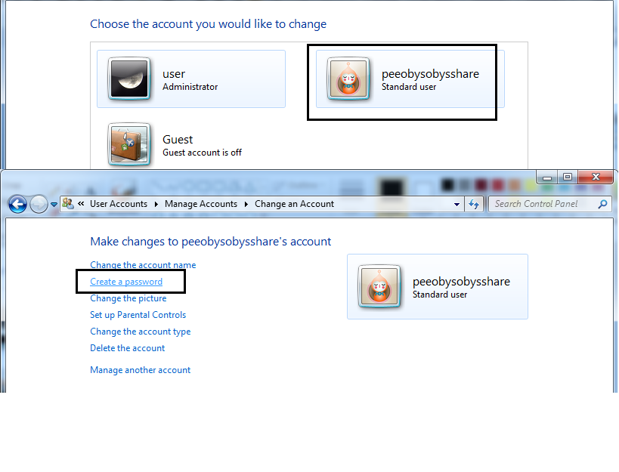

- Fill in the password, and then click Create a password.
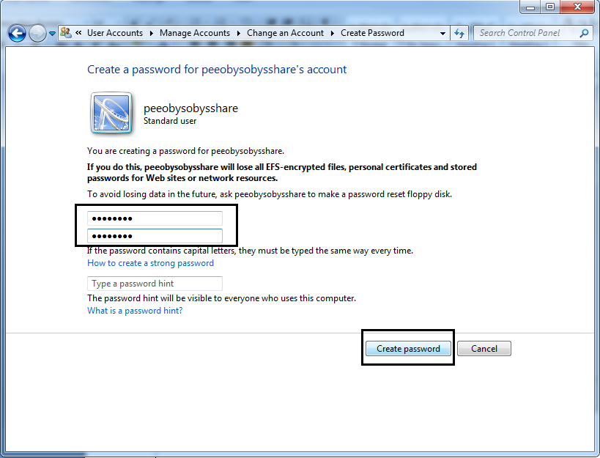
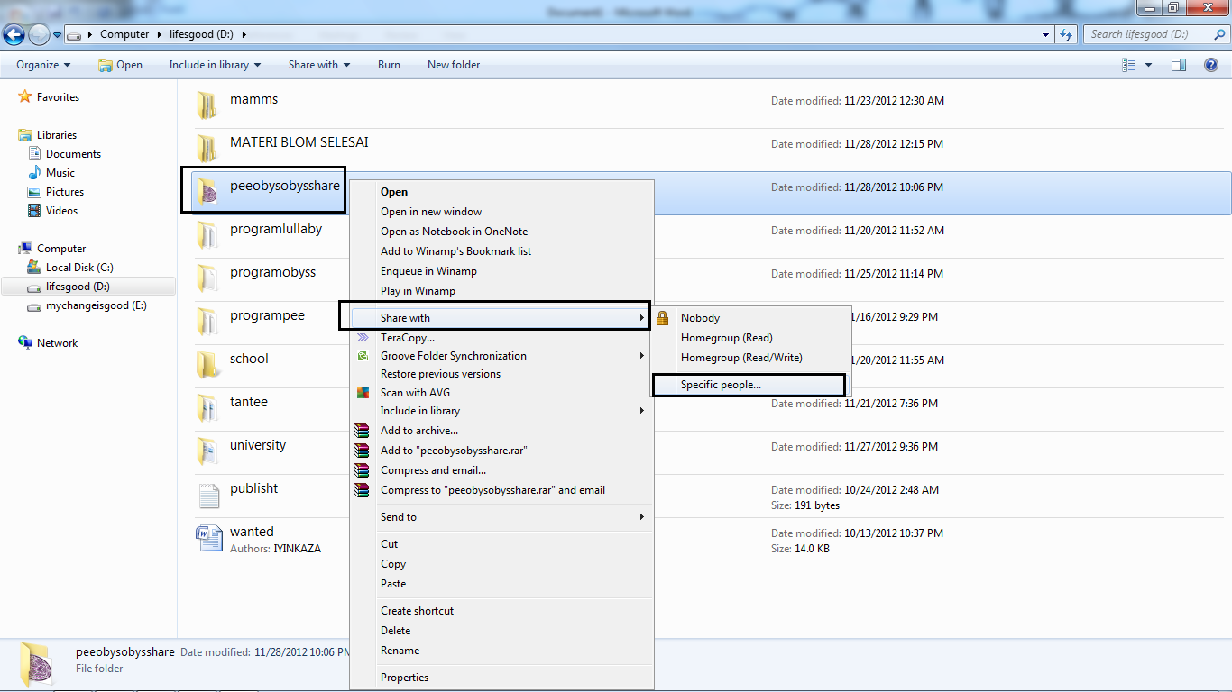
- Then select the folder you want to share, right-click, select Share with and choose specific people ...

- Fill in the username that was created earlier, click Add, then click Share.
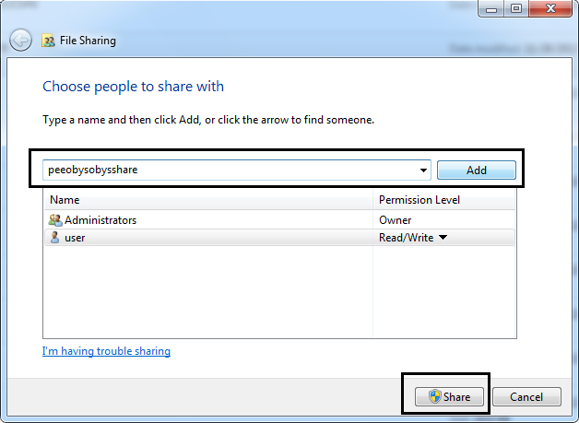
- Wait a few moments, and then click Done. Folder will be shared by the state indicated it says on the bottom of the window.
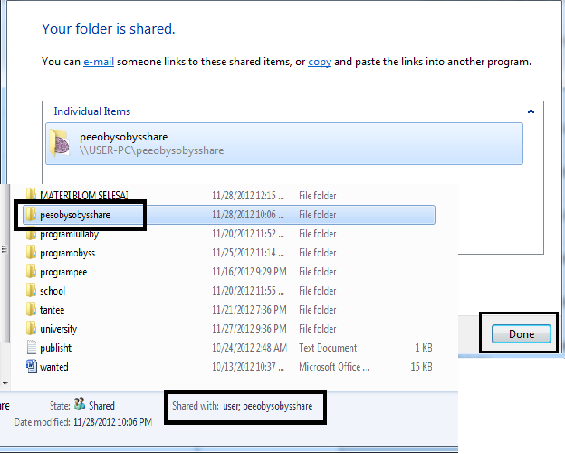
Note: The username and password have been created to be used by another computer when you open a folder share.

