“MEMORY SYSTEM”

- DEFINITIONS
The system is a union of elements interconnected to form a group to carry out the goal. Memory is a device or medium in which information (data) or instructions (commands) that can be stored and released again. Thus, the memory system is an interconnected unity in a tool which is to be found the information / data that can be stored.
- Structural / FUNCTION
Memory function to store information temporarily or for a long time, where the information can be retrieved at any time again. In addition, the functioning process data and instructions. More memory available, the more data and instructions can be processed. Memory is the computer data storage media, which in computer data storage media is divided into 2 types:
- INTERNAL MEMORY
This type of memory can be accessed directly by the processor. The internal memory has a function as a reminder. In this case stored in the main memory can be either data or program. Ordinary memory is divided is divided into two kinds: ROM and RAM. In addition, there are also the so-called CACHE MEMORY memory, CMOS, DRAM, SDRAM, DIMM.
- ROM (Read-Only-Memory a.k.a firmware)
ROM is a type of memory whose contents are not lost when without power and at first it can only be read. ROM on a computer provided by the computer vendor and contains the program or data. In the PC, called ROM BIOS (Basic Input / Output System) or the ROM-BIOS.
- RAM (Random-Access Memory).
Is a type of memory whose contents can be changed during the computer is turned on and is volatile. This memory is the main memory, used for memory functions to read and write data.
- CACHE MEMORY.
Limited memory capacity, high speed memory and is more expensive than main memory. Located between main memory and the processor registers, serves to processors not directly refer to the main memory but in the cache memory access speed is higher, the method uses the cache memory will improve system performance. Cache memory is the fastest RAM type and is used by the CPU, hard drive and some other components.
- CMOS (Compmentary Meta-Oxyde Semiconductor).
Is a type of chip that requires power from the battery. This chip contains 64-byte memory whose contents can be replaced. In these various settings of basic CMOS computers do, such devices are used to load the operating system and including the date and time of the system. CMOS merupukan part of the ROM.
- DRAM (Dynamic RAM).
Is a type of RAM should periodically refreshed by the CPU that the data contained in them is not lost.
- SDRAM (Sychronous Dynamic RAM).
Is a type of RAM that is a continuation of DRAM, but has been synchronized by the system clock and has a higher speed than DRAM.
- DIMM (dual in-line memory module)
Capacity of 168 pins, both memory module is active, every surface is 84 pin. Mensuport 64 bits of data delivery.
- EXTERNAL MEMORY
An additional memory function to store data or programs. Example: Hard drive, Floppy Disk etc.. The external memory is the hardware to perform a write operation, reading and storing data outside of main memory. External memory has two main objectives, namely as a permanent storage to RAM and the help function to get a cheap high-capacity memory for long-term use. These various types of external memory, such as:
Based on the type of data access, into two types:
- DASD (Direct Access Storage Device), where he has direct access to the data. Example:
      - Magnetic (floppy disk, hard disk).
      - removeable hard disk (Zip disk, Flash disk).
      - Optical Disk.
- SASD (Sequential Access Storage Device), indirect data access (sequential), such as magnetic tape.

- PRINCIPLES OF WORKING MEMORY COMPUTER
In this system, memory is a numbered sequence of bytes (like "cell"), each containing a small piece of information. Cells may contain data that computers need to perform a command. Memory stores various forms of information as binary numbers. The information will not be solved in the form of binary (encoded) with a number of instructions that convert it into a number or sequence of numbers. More complex instructions could be used to store images, sound, video, and various kinds of information. The information can be stored in a single sell is called a byte.

C. RELATIONSHIP WITH ORGANIZATIONS
- BUS
Also called pathway, a circuit which is the transport of information between two or more devices in a computer system. The bus that connects the CPU to the main memory is called internal bus, while connecting the CPU with the tools input / output bus called external. Here are the types of buses, among others:
- Data bus, the bus is used to transport data and instructions.
- Address bus, the bus is used for transportation to an address in main memory for data or instructions to be taken or recorded.
- Control bus, the bus is used to transmit signals as notification will be sent an information or receipt of information that is sent from one device to another.

- I / O PORT
An input / output to communicate with the CPU by sending the information to be communicated through the bus. Information sent from an input / output (peripheral device) to main memory or to a register in the CPU is placed in the I / O ports, and sent via the data bus. Similarly, if information from the main memory will be sent to the peripheral device via a data bus and also received at the I / O port. This method is also called the program-controlled I / O.
- DMA CONTROLLER
When information is sent once per block and the CPU should always keep an eye on the transmission of information, it will be a waste of time (idle time). DMA (Direct Memory Access) is a concept that will make the communication of information between the peripheral device to the main memory will be more efficient. DMA controller having a processor alone inside a special IC which will handle read and write operations between main memory and peripheral devices. How DMA is typically used for devices that have a high-speed peripherals that require delivery of large blocks of data, such as a hard disk drive.
- I / O CHANNEL
I / O Channel is a DMA controller is used together a number of tools for I / O. Each device I / O connected to a channel via a controller. A controller can be used for a number of devices I / O type, for example, will use two or more disk drives on a computer.

D. DEVELOPMENT OF MEMORY
Here is the type of memory and the development of brief explanation, among others:
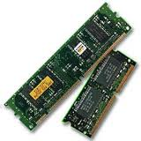
- RAM stands for Random Access Memory invented by Robert Dennard and produced on a large - scale by Intel in 1968, long before the PC invented by IBM in 1981. At the beginning of creation, requires a voltage of 5.0 volts RAM to run at a frequency of 4.77 MHz, with the memory access time (access time) approximately 200ns (1ns = 10-9 seconds).

- D R A M (Dynamic Random Access Memory). Dynamic Named because of the type of memory at any given time interval, always update the information or content validity. DRAM has a varied work frequencies, ie between 4.77 MHz to 40MHz.
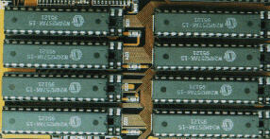

- FP DRAM, Fast Page Mode DRAM discovered around 1987. Since its launch, this type of memory directly dominate memory marketing, and people often refer to this type of memory "DRAM", without naming the FPM. This type of memory works like an index or table of contents. Meaning Page itself is part of the memory address contained in a row. When the system requires the contents of a memory address, FPM simply take information about them based on an index that has been owned. FPM allows for faster data transfer on the line (row) of the same from the previous memory type. FPM works in the frequency range 16MHz to 66MHz with 50ns access time around. Additionally FPM can process data transfer (bandwidth) of 188.71 Mega Bytes (MB) per second. FPM memory is more often used on systems based on Intel 286, 386 and 486 bit.
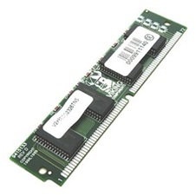

- EDO RAM (Extended Data Output Dynamic Random Access Memory). Memory EDO read cycle can shorten it so that it can improve the performance of about 20 percent. EDO has access time is quite varied, which is about 70ns to 50ns and works at a frequency of 33MHz to 75MHz. EDO DRAM memory systems based on the widely used Intel 486 and Pentium compatibles and early generation.
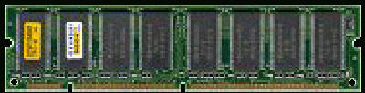

- PC66 SDRAM. Synchronous Dynamic Random Access Memory, SDRAM is then better known as PC66 because it works on a 66MHz bus frequency. SDRAM only requires a voltage of 3.3 volts and has an access time of 10ns. Socket 7 processor-based systems such as the Intel Pentium Classic (P75 - P266MMX) nor compatibles from AMD, WinChip, IDT, and so can work very quickly by using this PC66 memory. Even Intel Celeron II earlier generations still using PC66 SDRAM memory system.
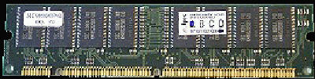

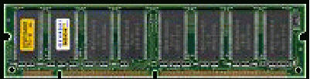
- PC100 SDRAM, Intel made ​​the new standard type of memory which is the development of memory PC66. The new standard was created by Intel to balance the system with the system chipset i440BX Slot 1 is also created by Intel. This chipset is designed to work on a bus frequency of 100MHz. Because the bus system works at a frequency of 100MHz while Intel still wants to use SDRAM memory system, it is developing SDRAM memory that can work at 100MHz bus frequency. Like its predecessor PC66, SDRAM memory is then known as PC100. Using the working voltage of 3.3 volts, PC100 memory has an access time of 8ns, shorter than PC66. Additionally PC100 memory capable of 800MB of data stream per second.

- DR DRAM, In 1999, Rambus creates a memory system with a new architecture and a revolutionary, totally different from SDRAM memory architecture. This memory is called Direct Rambus Dynamic Random Access Memory. By simply using a voltage of 2.5 volts, which works on RDRAM 800MHz system bus via a bus system called Direct Rambus Channel, able to stream data at 1.6 GB per second (1GB = 1000MHz). DRDRAM sophistication but can not be utilized by the system chipset and CPU at that time so that the memory of this lack of support from various parties. In addition, this memory is less desirable because the price is very expensive.
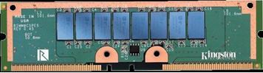

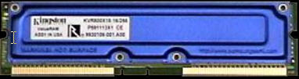
- PC800 RDRAM, Still in the same year, Rambus has also developed an other memory types with the same capabilities as DRDRAM. The difference lies only in the working voltage is needed. If DRDRAM requires a voltage of 2.5 volts, the PC800 RDRAM work on voltage 3.3 volt.

- PC133 SDRAM. As the name implies, PC133 SDRAM memory works at 133MHz bus frequency with an access time of 7.5 ns and was able to stream data at 1.06 GB per second. Although it was developed to work on the PC133 bus frequency 133MHz, and the memory is also capable of running at 100MHz bus frequency, although not as good as the capabilities of the PC100 at that frequency.
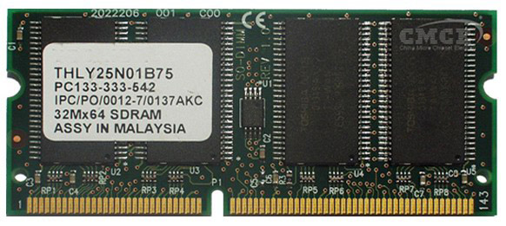

- SDRAM PC150, in 2000 successfully developed a memory chip that is able to work at a frequency of 150MHz bus. working voltage of 3.3 volts, PC150 memory has an access time of 7ns and able to stream data at 1.28 GB per second. Memory is intentionally created for the purposes of overclockers, but the user gaming applications and 3-D graphics, desktop publishing, and computer servers can take advantage of the presence of PC150 memory.
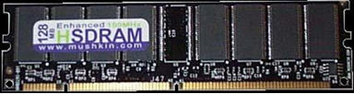

- DDR SDRAM, still in 2000, successfully developed Crucial SDRAM memory capacity doubled. The technique used is to use the full one wave frequency. This memory is called DDR SDRAM stands for Double Data Rate Synchronous Dynamic Random Access Memory. With DDR SDRAM memory, system bus with a frequency of 100-133 MHz will work effectively at a frequency of 200-266 MHz. DDR SDRAM was first used in ultra high-speed AGP graphics card. While the use of the processor, AMD ThunderBird was the first to use it.
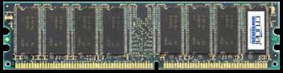

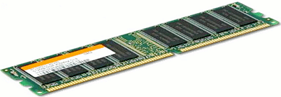
- DDR RAM, two large companies in 1999 microprocessor INTEL and AMD compete in increasing the clock speed on the CPU. But the obstacles, because when increasing memory bus to 133 Mhz needs Memory (RAM) will be larger.

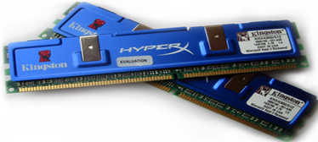
- DDR2 RAM, when the memory type DDR (Double Data Rate) perceived the rapid slowing down the performance of the processor and the graphics processor, DDR2 memory is the presence of a logical progression in memory technology refers to the addition of speed and anticipation of the wide triangular access processors, memory, and interfaces graphs (graphics card) that comes with the computational speed is doubled. That is, technological advances on DDR2 requires less power to write and read in memory.

- DDR3 RAM, has the power requirement is reduced by approximately 16% compared to DDR2. This is because DDR3 is already using 90 nm technology so konsusmsi 1.5v power is required, much less when compared to DDR2 and DDR 2.5V 1.8v. In theory, the speed of which is owned by the RAM is quite riveting. He was able to transfer data at an effective clock of 800-1600 MHz. In the 400-800 MHz clock, much higher than DDR2 at 400-1066 MHz (200-533 MHz) and DDR at 200-600 MHz (100-300 MHz). The prototype of DDR3 has 240 pins. It's actually been introduced long ago in early 2005. However, the product itself is really emerged in mid-2007 along with a motherboard that uses the Intel P35 chipset and the motherboard Bearlake supports DIMM slots.
