"3 MISSIONARIES AND 3 CANNIBALS"

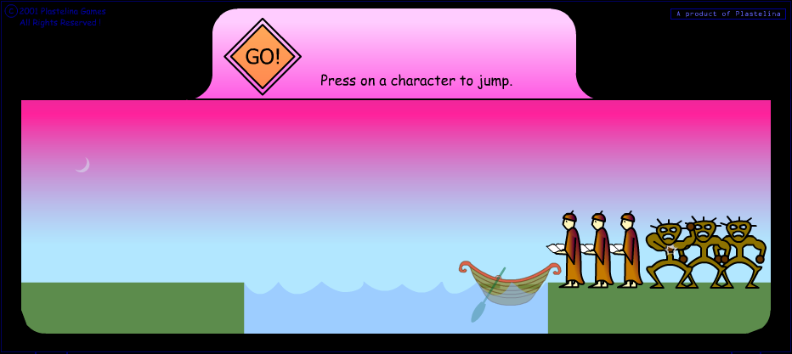
Description:
- Missionaries and cannibals are on the right.
- There are 1 boats, with a capacity of 2 (Two) to be on the move.
- Missionaries were given recognition by M1, M2 and M3.
- Cannibal given identifier with K1, K2 and K3.
- All the missionaries and cannibals moved to the left.
The solution steps:
- Move 2 cannibals (K1 and K2) to the left.
- Cannibal (K1) is placed to the left, then Cannibal (K2) back to the right.
- Cannibal Move Again (K2 and K3) to the left.
- Cannibal (K2) were placed on the left, until there are two cannibals (K1 and K2).
- Cannibal (K3) back to the right, and then removed from the boat.
- Fill two missionaries (M1 and M2) to the boat to the left. So the right size of the remaining cannibals (K3) and missionaries (M3).
- Following up on the left, remove the Missionaries (M1), and Cannibal (K2) were placed on the boat. Until there is a cannibal (K2) and missionaries (M2) back to the left.
- Remove Cannibal (K2), and fill two missionaries (M2 and M3) to the boat to the left, up on the right side of the remaining 2 cannibals (K2 and K3).
- Remove the two missionaries (M2 and M3) to the left, then cannibals (K1) back to the right to pick up cannibal (K2) to be moved to the left.
- After being on the left, move Cannibal (K1). Until there are 3 missionaries (M1, M2 and M3) and cannibals (K1).
- Cannibal (K2) back again to the right to pick up cannibal (K3) to be moved to the left.
- Until finally there were three missionaries (M1, M2 and M3) and 3 cannibals (K1, K2 and K3) on the left.

